**Shelf Label – print single label project**

We would like to add a new button to the Inventory Item form named “Shelf Label”

*NOTE: The current “Print Label” button is a similar implementation that Velosio put in place for us. Highlighting it as we think it should be fairly straight forward to copy that functionality and make the necessary changes to the fields and formatting of the label.*

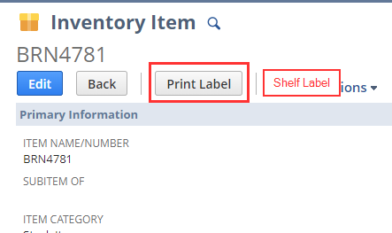

This button would allow the user to print the following label format for the selected item. 2 examples below.

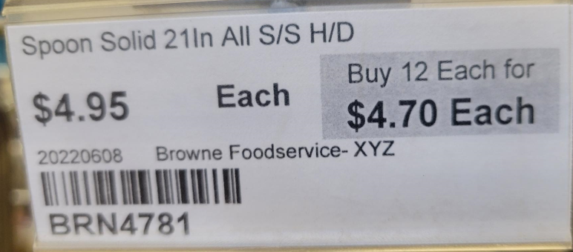

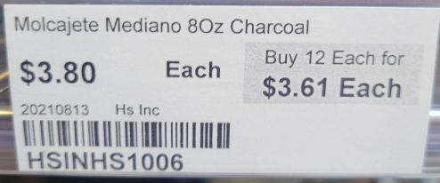

**Fields:**

Short Description (10pt font)

Retail Price (16pt) Primary Sales Unit (16pt) (If qty pricing schedule is in place for the item.) Text “Buy {qty break} {Primary Sales Unit} for”

Qty pricing Amount (16pt)

Vendor (8pt)

Barcode (14pt)

Item ID (14pt)

**Label dimensions:** 1.25” X 3.0”

